

Carers Support West Wales

Annual Report

IMPROVING ACCESS TO ONLINE INFORMATION & SUPPORT FOR UNPAID CARERS IN WEST WALES
1st APRIL 2025 - 31ST MARCH 2026

Authored by: Sophie Buckley (PAVS) on behalf of West Wales Carers Development Group



Executive Summary
Carers Support West Wales (CSWW) continues to provide a trusted, accessible source of information, advice and support for unpaid carers across Carmarthenshire, Ceredigion and Pembrokeshire. Working collaboratively with unpaid carers, statutory partners and third sector organisations, the project supports the delivery of the West Wales Strategic Plan for Unpaid Carers by helping unpaid carers access timely information and services that improve wellbeing and resilience.
During 2025-26, the CSWW website remained a vital source of information for unpaid carers and professionals, offering comprehensive resources on unpaid carers' rights, financial support, health and wellbeing, local services, and emergency planning. The website continues to be co-produced with unpaid carers and partner organisations to ensure information remains accurate, relevant and accessible.
At a Glance 2025-26
151,831 website visits | 324,395 social media engagements | 237 survey responses received
100% of respondents rated the website as useful | 3 county areas supported across West Wales | 1 shared regional resource delivering consistent information for unpaid carers and professionals

Key Achievements
Supporting unpaid carers through accessible information - The website continued to provide a comprehensive, regularly updated digital information hub, enabling unpaid carers to access support, guidance and local services when and where they need them.
Working in partnership - CSWW strengthened collaboration with statutory, health and third sector partners, ensuring unpaid carers could access consistent information across organisations and services throughout West Wales.
Co-production with unpaid carers – Unpaid carers remained central to the development of the project. Feedback from surveys, engagement activities and direct contact informed content development and service improvements throughout the year.
Raising awareness - Through targeted digital communications and social media activity, CSWW increased awareness of support available to unpaid carers and signposted individuals to local and regional services.
Developing new resources - The project continued to expand and improve resources in response to emerging needs, including information supporting hospital discharge, contingency planning and unpaid carers' rights.

Impact
Feedback received during the year demonstrates that unpaid carers value the website as a trusted source of information that helps them:
- Understand their rights and entitlements.
- Identify local sources of support.
- Navigate health and social care services.
- Feel more informed and confident in their caring role.
- Access support earlier and more effectively.
The project continues to contribute to improved outcomes for unpaid carers by reducing barriers to information, increasing awareness of available support and strengthening connections between unpaid carers and services.

Looking Forward
In 2026-27, Carers Support West Wales will continue to develop and enhance its digital resources to ensure they remain accessible, relevant and responsive to the needs of unpaid carers across the region. Working alongside unpaid carers, partners and stakeholders, the project will continue to embrace co-production principles to shape future developments and ensure that information and support reflect the changing needs of unpaid carers. By maintaining a strong focus on accessibility, collaboration and innovation, CSWW will continue to provide a trusted source of information and support, helping unpaid carers across West Wales to identify and access the services, resources and opportunities available to them. To build on the success and impact achieved to date, CSWW will also seek continued investment and long-term support to ensure the website remains sustainable, up to date and well-positioned to meet the needs of unpaid carers and professionals for years to come.

Background and strategic link
Since November 2022, unpaid carers of all ages in Carmarthenshire, Ceredigion and Pembrokeshire have had access to a bespoke regional website to help support them in their caring role. The website supports the provision and accessibility of consistent information, assistance and advice for unpaid carers across the three counties, which unpaid carers told the West Wales Carers Development Group was important to them in a survey to develop the West Wales Carers Strategy in 2020.

On the launch of the website, Judith Hardisty, then Hywel Dda University Health Board Vice Chair, Carers Champion, and Chair of the Regional Partnership Board (RPB) said:
“I am delighted that the Carers Support West Wales website will provide a bilingual ‘one stop shop’ for unpaid carers helping them to easily find information to support them in their caring role. The website will include details of local groups and activities, as well as relevant and timely help and support on benefits and financial entitlements. We know that people don’t always recognise themselves as unpaid carers, so won’t be aware of the help and support which is available to support them in their caring role, therefore this new website will be a valuable resource for everyone. The Regional Partnership Board are grateful for the contribution of all our unpaid carers who care for family and friends in their own communities and are committed to ensuring that the needs of unpaid carers are addressed.”

The website, Carers Support West Wales (CSWW), is a one stop shop for carer specific information and has been co-produced with unpaid carers in the region. It continues to help the West Wales Regional Partnership Board to deliver against the West Wales Strategic Plan for Unpaid Carers 2025-2030, which identifies three key aims under Priority 2 “Carers are Supported”.

- Ensure the right information is available at the right time
- Ensure that unpaid carers receive support
- Offer a range of services to respond to unpaid carers’ needs

Across West Wales, unpaid carers can access information, advice, assistance and ongoing support through a network of dedicated services, including county-based Carers Information Services and Young Carer services. These services provide support throughout the caring journey, offering a range of practical, emotional and preventative support, including access to unpaid carer breaks. This support is complemented by the Carers Support West Wales website, which acts as a central regional hub for online information and resources. The Carers Support West Wales website, combined with proactive outreach through social media and drop-in sessions, have significantly improved access to support for unpaid carers. This partnership approach has created a more responsive, accessible and sustainable system that supports unpaid carers both in times of crisis and in building longer-term resilience.

The Carers Support West Wales (CSWW) website remains the central online hub for information and support, receiving 151,831 visits between 1 April 2025 and 31 March 2026, alongside 324,395 engagements across associated social media platforms, including Facebook and Instagram. This reflects increased regional awareness, effective promotion, and successful search engine optimisation, positioning it as a leading online resource for unpaid carers.
"I had no idea I was entitled to a Carer’s (Needs) Assessment until I read their website. That single piece of information opened doors to support I didn't even know existed."

CSWW has been developed to complement existing websites and provisions. The website offers a quick and easy way to find carer specific information for the three counties.

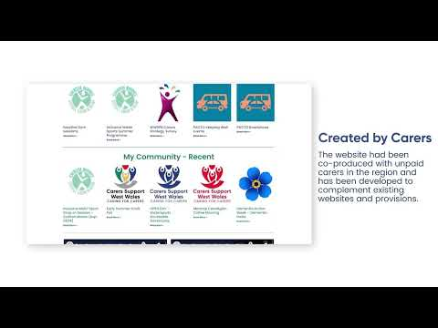

Carers Support West Wales is divided into three distinct sections, allowing unpaid carers to easily navigate the platform and explore information locally and regionally.
- On the ‘My Community’ section, unpaid carers will find local offers, promotions and discounts that can support them in their caring role in their community. An interactive map provides a quick visualisation of any activities close by as well as the relevant contact details.
- The ‘Support’ section provides support that is felt could benefit them as an unpaid carer such as how to register as an unpaid carer with your GP and how to register for a Carers Recognition Card. Using a filter system to navigate this, unpaid carers will be able to search a number of local and national organisations to find the information they need.
- The ’News’ section shares essential information that is timely and relevant, from a list of support with cost-of-living crisis to unpaid carers magazines providing local and national information that may be useful to unpaid carers and professionals.

The website design, branding and content is developed through coproduction and engagement with unpaid carers and providers throughout the region.
For more information, please visit https://carerssupportwestwales.org or contact info@carerssupportwestwales.org
@carerssupportww
#caringforcarers
#gofaluamofalwyr

The project’s continuing aim is to support unpaid carers in West Wales to access information to support them in their caring role, increasing self-sufficiency and independence. The information they access can reduce escalation to higher risk and more complex services. Having access to information digitally means those who are unable to leave home due to their caring responsibilities or overcome barriers such as travel to access information can still access support without the need to access services by traditional methods. The digital marketing & promotion of support means we can reach hidden unpaid carers before they reach crisis point, ensuring they feel more supported in their caring role.

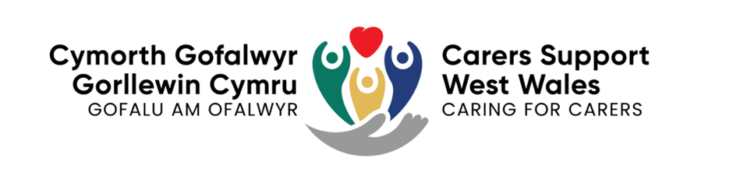

Co-production

The website design, branding and content continue to be developed through co-production and engagement with unpaid carers and providers throughout the region. We are continuously gathering feedback from unpaid carers on website development and future content.
- A feedback form has been installed onto the website to capture visitor experience and to gather ideas for improvements and future development.
- We are also constantly engaging with hidden unpaid carers and those new to the website through our social media channels and at community events across the Region.
- We also take feedback and guidance from our Steering Group and Carers Provider Forums. For example, during the cost of living crisis we added information on support initiatives such as Keep Warm, Keep Well in Pembrokeshire, or Short Breaks for Carers, in response to concerns around the increasing cost of caring. This included developing two new sections on the website for this information. We also developed some short videos to support unpaid carers with income maximisation which are hosted on the website.
Unpaid carers continue to be a big part of the future development of the website as we ensure it continues to stay up to date, relevant and useful.

Partnership & collaboration

Acting on behalf of the West Wales Carers Development Group, Pembrokeshire Association of Voluntary Services (PAVS) was awarded funding from the Welsh Government’s Integrated Care Fund (ICF) and now the Regional Integration Fund (RIF) to develop and maintain a bilingual regional carers online platform. The project is delivered by PAVS (Pembrokeshire Association of Voluntary Services) on behalf of the West Wales Carers Development Group and continues to be guided by a multi-agency Steering Group - members include representatives from Carmarthenshire, Ceredigion and Pembrokeshire County Councils, and Hywel Dda University Health Board.

Carers Support West Wales continues to promote opportunities for unpaid carers to have their voice heard in the development of services and support by promoting engagement and co-production activity of statutory partners. This year has included promoting the Regional Carers Strategy refresh survey, the West Wales Public Sector Boards Wellbeing Assessment survey, Hywel Dda UHB Pharmaceutical Needs Assessment, Carmarthenshire Improving Community Wellbeing survey and Hywel Dda Digital Access and Inclusion survey, amongst many others. The website also shares the West Wales Regional Partnership Board newsletter on the website and socials to help share the work of the RPB.

The Carers Support West Wales project also engages in projects that offer digital inclusion opportunities for unpaid carers. This includes opportunities for Virtual Reality short breaks and tablet loan schemes, such as the scheme delivered in Pembrokeshire through the Community Connector service. All unpaid carers who access the loan scheme receive a tablet with a shortcut link to Carers Support West Wales, as well as other personalised links depending on their interests and support needs.

Carers Support West Wales links with a number of partners across the Region to promote the website to the public including Pure West Radio and the Pembrokeshire Community Hub.

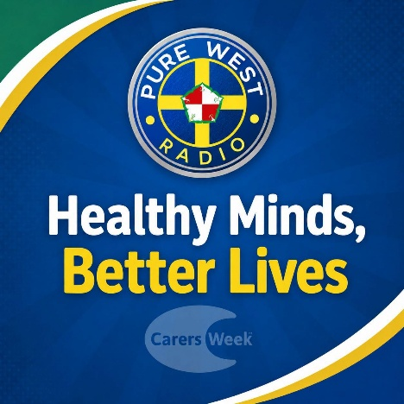

The website continues to receive support locally and nationally, as it is recognised as being a source of reliable, up to date and vital information for unpaid carers and those who support them, including practitioners in Hywel Dda UHB, the three Local Authorities and the voluntary sector across the Region.

“I made contact using the contact form on the website. She signposted me to the Carers Hospital Discharge Officer who had valuable advice for those leaving hospital in a caring role. She also signposted me to the information on the website and gave me a list of important numbers and services the gentleman could access for more help.”

Hywel Dda University Health Board Nurse
“Discovering the Carers Support West Wales website has been extremely useful in my work as an Occupational Therapist. The level of information and detail available makes it a valuable resource for both professionals and families looking for local support. I was very impressed with how much information was available and how it can help connect people with the services they need within their communities.”

Occupational Therapist working in Carmarthenshire

Impact

What difference is the website making?

The Carers Support West Wales website remains the central online hub for unpaid carers information and support in the Region, receiving 151,831 website visits between 1 April 2025 and 31 March 2026, alongside 324,395 engagements across associated social media platforms. This reflects increased regional awareness, effective promotion, and successful search engine optimisation, positioning it as a leading online resource for unpaid carers.

 | 2022-23 | 2023-24 | 2024-25 | 2025-26
Website visits | 27,020 | 47,691 | 187,687 | 151,831
Social media interactions | 289,964 | 370,498 | 410,817 | 324,395
Number of people taking part in website survey | N/A* | 264 | 321 | 237
Number of people satisfied with information provided? | N/A* | 98.5% | 100% | 100%
Number of people who rated their experience as Good or excellent? | N/A* | 98.5% | 100% | 100%
*Survey introduced the following year

Following four years of strong growth, the Carers Support West Wales website is now an established and widely recognised resource across the region. While website visits and social media engagement have started this year to level off, this was expected and is likely to reflect the maturity of the service, changes in online behaviour and evolving methods of measuring digital activity, rather than a reduction in need. The website continues to provide a trusted source of information for unpaid carers and remains an important part of the wider support network across West Wales. Going forward, the focus will be on maintaining high-quality information, improving accessibility and measuring meaningful engagement and outcomes alongside headline visitor numbers.

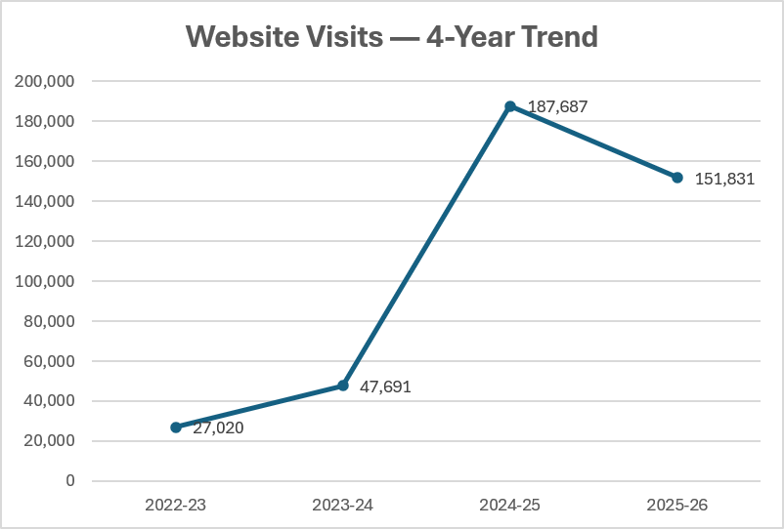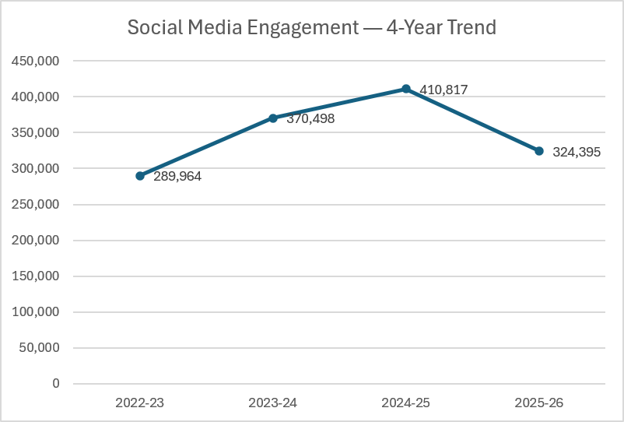

User feedback gathered through an online survey further evidences the impact of the website. Of the 237 survey respondents, 100% reported satisfaction with the information provided, with 70% rating their experience as good and 30% as excellent. This feedback provides strong assurance that the website meets unpaid carers’ information needs and supports positive user experiences.

The website has also developed a dedicated section providing guidance for unpaid carers when the person they support is in hospital or being discharged. To enhance accessibility, a short video has been developed, featuring a lived experience case study. The video is hosted on the Health Board’s YouTube channel and linked directly from the Carers Support West Wales website to drive visits. It has been widely shared across hospital sites, mental health services and third sector organisations and by the end of December 2025, there had been 264 views in English and 49 in Welsh, further supporting awareness and engagement.
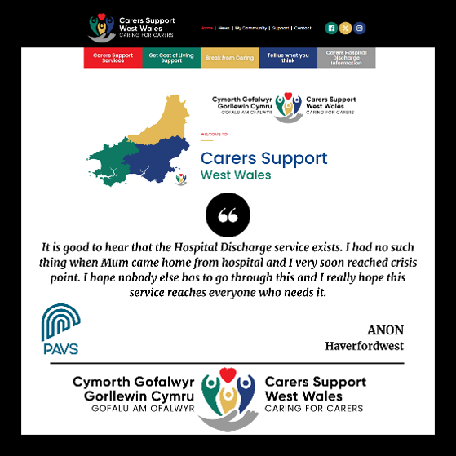
The following data is an example of a snapshot of the top pages visited on the CSWW website. This data gives us a good understanding of what visitors to the website are looking for. This data has been used by the West Wales Carers Development Group, along with engagement with unpaid carers and providers, to help refresh the West Wales Carers Strategic plan.

 | 1 | 2 | 3 | 4 | 5
Top 5 Pages visited | Carers Support Services | Community Team Learning Disability | Cariad Pet Therapy | Dementia Friendly Communities | CATCHUP Benefits Advice Service
Top 5 Searches | Carers Support West Wales | Catch up llanelli | Cartref cynnes carmarthen | Ctld llanelli | Attendance allowance wales

Here is some of the feedback we have received from unpaid carers this year:

“My partner has MS, and caring for him can be exhausting. Your posts on Facebook have given me permission to take care of myself. I have enjoyed many of the Me Time sessions and Creative Time Out for Carers. Thank you.”

“It’s hard to explain what being a parent carer is like. Thanks to the resources on here [CSWW website], I have been able to apply for support I didn’t even know we were entitled to. It’s made such a difference for our family.”

“Thanks to the Carers Support West Wales website, I discovered support groups and services I didn’t even know existed. It’s made such a difference in my daily life as a carer and given me confidence to care for my Dad.”

“I came across the Carers Recognition Card while browsing the Carers Support West Wales website and didn’t realise before just how many places accepted it for discounts. The information was really clear and helped me understand how to apply and where I could use the card locally. It’s made a real difference to know that my role as a carer is recognised, and the small discounts help make days out and everyday spending a little easier.”

“Using the Carers Support West Wales website helped me discover inclusive sports groups for my wheelchair-bound mum, especially sessions she could actually take part in. Getting involved has really boosted her confidence, and I’ve met other carers who understand our situation. It’s been wonderful to see her make new friends — and I’ve made some great connections too.”

“Having information in one place, online, is essential for many carers. We don't always have the time to make phone calls or attend a meeting during office hours, so online information which can be found in the middle of a sleepless night or whilst scrolling through social media is really valuable. I also appreciate how Carers Support West Wales provides constant updates of events, which can't be covered by a printed newsletter as new things come up all the time.”

Case studies gathered for Welsh Government Regional Integration Fund (RIF) reporting



We have delivered the following engagement, promotion & development activities this year:

- Carers Support West Wales Steering group continues to meet on a regular basis, chaired by PAVS Strengthening Communities Programme Manager/Project Lead. Members continue to include all 3 Local Authorities and the Health Board who all plan and support the direction of the project.

- Promotion and marketing of Carers Week & Carers Rights Day 2025 activities across the 3 Counties, including provision of marketing materials for events.

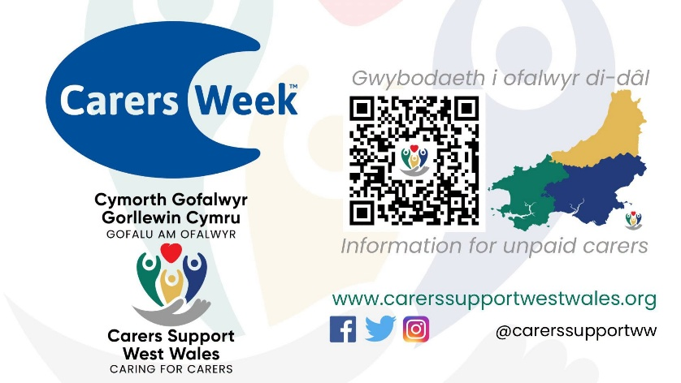 | 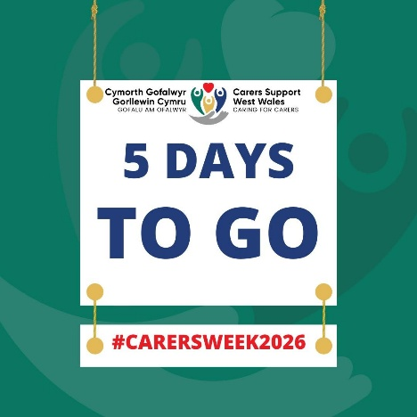

- Continued promotion of Carers Support West Wales across the Region, both face to face at events and on social media. https://www.facebook.com/carerssupportww

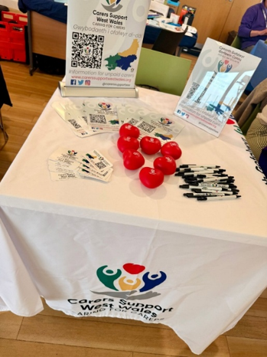

- The project supported the development of a promotional campaign for the Carers Hospital Discharge Support Service with Health Board and third sector colleagues.

- Worked with Pembrokeshire County Council to develop branding for the recommissioned adult Carers Support Pembrokeshire and Young Carers Support Pembrokeshire services, which ties in seamlessly with the branding for Carers Support West Wales.

- We have shared funding opportunities for unpaid carers groups across the region.

- We have shared information on behalf of voluntary organisations and community groups who want to promote their group or activity to more unpaid carers.

- Pure West Radio interviews to promote CSWW, including during Carers Week.

During 2025-26, Carers Support West Wales continued to demonstrate its value as a trusted, regional source of information and support for unpaid carers. Through strong partnership working, co-production and digital engagement, the project has supported thousands of unpaid carers to access services, improve wellbeing and remain resilient in their caring roles.

For more information, please contact info@carerssupportwestwales.org or visit www.carerssupportwestwales.org

