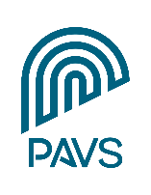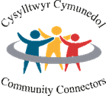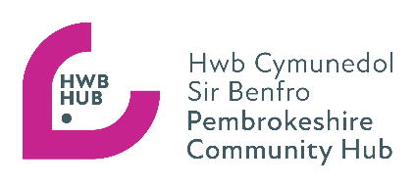

Background information:

PAVS delivers the Pembrokeshire Strengthening Communities programme in partnership with Pembrokeshire County Council and Hywel Dda University Health Board. The programme consists of several preventative services delivered by a team of staff all working towards the same vision:

“Working with Pembrokeshire communities to be active, connected, resourceful and sustainable places where people can live well”

The programme consists of 3 key areas
- Community Connectors
- The Pembrokeshire Community Hub
- Engagement, Influencing & Co-production

The Community Connector service is a preventative, community-based, citizen-centred approach to improving health and wellbeing in Pembrokeshire, beginning with a strengths-based What Matters conversation and often involving social prescribing linked to the 5 Ways to Wellbeing and working in a place-based way as part of multi-disciplinary teams around GP surgeries. The Connectors often provide signposting support to individuals to maintain their independence at home and within their communities for as long as possible. The Community Connector team currently comprises of eight practitioners working in six integrated community health areas across Pembrokeshire, plus two Community Connector - Children, Families & Young People (CFYP) posts to ensure that we provide a service to everyone in the community.

Last year, over 1500 referrals were received from across health, social care, voluntary sector and self-referrals too. The Community Connectors work with individuals and their families to co-create a strengths-based wellbeing plan leading to introductions being made to appropriate community activities, groups and services. People are supported to access services to provide support with befriending, income maximization, energy advice etc. 91% of people reported achieving their personal outcome as a result of working with a Community Connector. The Community Connectors also support people to become digitally included. The Community Connector Speed Network was relaunched in March 2025 to coincide with National Social Prescribing Day. Over 40 practitioners from across the sectors attend these biannual networking events.

The Pembrokeshire Community Hub is a multi-agency partnership led by the third sector. It offers a “front door” to the Community Connectors service and provides triaged access to consortia programmes, such as Pembrokeshire Digital Connections, as well as supporting the day opportunities transformation programme and linking closely with the direct payments and social care teams within the Local Authority. The Hub continues to place itself as the starting point for community services for residents, visitors to the county and professionals. Last year the Hub handled over 4800 enquiries spanning food, finance, community activities/social connections, benefits, debt advice, care and support as well as digital connectivity. In partnership with the Local Authority and Health Board, the Hub organised 11 Keep Well community events last year, attended by 273 people and supported by the Community Connectors. The Keeping Well Events are designed for people to stay well and healthy for longer and to support people in self-managing conditions and improving their quality of life at home and in the community. The Hub and Community Connectors also support other community events such as the Llanrhian Winter Warmers lunch https://fb.watch/yUOx8_Vi3f/ The Hub has also arranged for the installation of 13 digital information touch screens across Pembrokeshire, including GP surgeries. The information on these screens is managed centrally by Hub staff from PAVS. There have been over 2500 touch screen exposures/clicks. The Pembrokeshire Community Hub is the single point of contact for Keep Warm, Keep Well support initiatives. The Hub promotes the support available in communities through various marketing and promotion methods including social media.

The Community Connector team is a key element of the vision for preventions in Pembrokeshire – “Working with Pembrokeshire communities to be active, connected, resourceful and sustainable places where people live well”. Each Community Connector has been allocated a geographical patch, broadly aligned to boundaries of the proposed Integrated Community Networks (ICNs) and linked to specific GP surgeries. Community Connectors respond to community referrals and self-referrals and also deliver social prescriptions referred through primary care. The Community Connector - Children, Families & Young People (CFYP) receives referrals from a wide range of sources and is part of the Pembrokeshire Family Support Network (PFSN), working in partnership with multi-agency colleagues to ensure the diverse range of community-based provision is included in the support offered to families.

Community Connectors are expected to support the work of the Hub, but their main focus is to prioritise referrals and self-referrals and to work in an asset-based and relational way in their geographical patches, working with elected members, town & community councillors, volunteers, voluntary and community groups and other link workers to build resourceful communities and improve individual and community wellbeing. Responding to referrals is a priority so Connectors will be expected to work as a team to pick up referrals from other areas across Pembrokeshire as required. The role involves travel for meetings, community engagement and home visits as required.

Both the Pembrokeshire Community Hub and Community Connector services receive strategic leadership and oversight from the Strengthening Communities Programme Manager at PAVS.
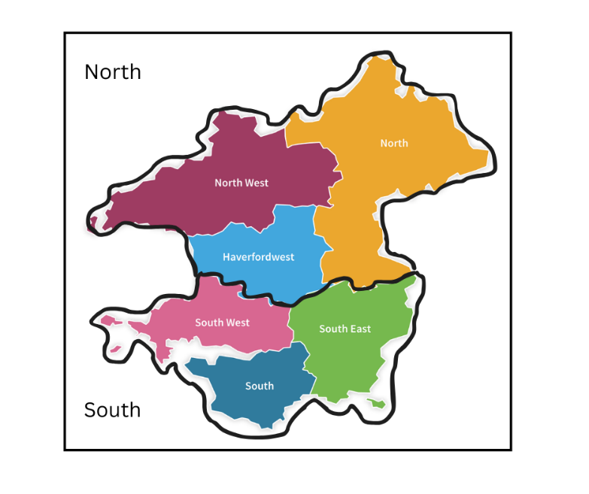

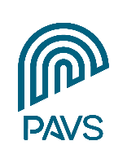
PEMBROKESHIRE ASSOCIATION OF VOLUNTARY SERVICES

JOB DESCRIPTION
Job Title: Community Connector - Children, Families & Young People (CFYP)
Hours: 37 hours per week to include evening and weekend work (as required)
Responsible to: Strengthening Communities Programme Manager
Location: South Pembrokeshire
Salary: £30,036 p.a.
Leave entitlement: 25 days per annum + 8 days public bank holidays

Aim of the post
To work collaboratively with individuals, voluntary and community groups, statutory services and other key stakeholders across South Pembrokeshire to deliver an asset-based preventions model for children, young people and families that improves health and well-being, through community connecting and strengthening community resourcefulness.
Main tasks and responsibilities – the post-holder will:

- Develop and grow the Community Connector for Children, Families & Young People (CFYP) role, building a network in the South Pembrokeshire area which will positively impact the CFYP community, by connecting them to sustainable preventative services.

- Work closely with the Pembrokeshire Community Hub, Pembrokeshire Family Support Network (PFSN), Social Care, Health, Education, Edge of Care, Youth Services and GP surgeries to offer a community connecting/social prescribing service to families who would most benefit from such support, ensuring that children and families are offered the widest range of opportunities to improve their wellbeing.

- Support the Local Authority’s prevention agenda and the development of a 0-25 preventions service, by supporting the setting up of new community-based provisions, creating additional resource. Early intervention and prevention are central to meeting the authorities’ priorities for the 0-25 cohort, one of these priorities being to reduce the number of young people entering residential care.

- On receipt of a referral/introduction, conduct a person-centred, strengths-based, trauma-informed, ‘What Matters’ conversation, to be held in a location agreed with the individual/family which could include their own home, community venue or public place (such as GP surgery or school/library), online or by telephone, identifying personal and local community networks and assets to find practical solutions to meet identified well-being goals and needs.

- Support the facilitation of the Pembrokeshire Children & Families Network of providers who support children, young people and families, to encourage collaboration and partnership working, disseminate information across the network, share learning and good practice.

- Promote digital inclusion by supporting individuals and families to make use of technology to connect with various forms of online support through the Pembrokeshire Digital Connections programme.

- Encourage and support local groups to upload and maintain up-to-date and relevant information about local services on infoengine, Dewis Cymru and Pembrokeshire Community Hub webpages, promote the on-line information resource to community members, voluntary and community groups, professionals and partners.

- Ensure that third sector groups working with children and families are signposted to appropriate support in respect of governance, safeguarding, quality assurance, volunteer management, etc.

- Attend meetings of local and regional partnerships that may be identified as being useful in terms of developing preventions services and community support for children and families

- Implement agreed systems for monitoring unmet need and service demand and, in liaison with PAVS and other relevant partners, support the development of appropriate third sector and partnership initiatives.

- Contribute to the development of the Wellbeing Assessment and achievement of the objectives set out in the Pembrokeshire Wellbeing Plan by mapping local assets and developing a thorough understanding of the needs of local people and communities.

- Maintain records of referrals, activity and outcomes achieved, using the social prescribing CRM platform, and produce regular monitoring reports and Most Significant Change stories to contribute to ongoing evaluations and demonstrate impact of the Community Connector service on wellbeing.

- Be prepared to use and contribute to regular supervision and be committed to personal development of skills and abilities, as required by the role.

- Carry out any other duties as required and agreed with PAVS, and as may be determined by the multi-agency Strengthening Communities Operational Group.

This post requires an Enhanced DBS check arranged by PAVS.

Key partners and stakeholders

- Pembrokeshire Family Support Network
- Pembrokeshire Community Hub
- Pembrokeshire County Council (including Social Care teams)
- Hywel Dda University Health Board (including S-CAMHS)
- Pembrokeshire Public Services Board partners
- PLANED
- West Wales Action for Mental Health (WWAMH)
- Public Health Wales
- GP surgeries and primary care community health professionals
- West Wales Regional Partnership Board
- Pembrokeshire Leisure/Libraries & Cultural Services
- Pembrokeshire County Council elected members
- Town & Community Councils
- Community Associations and Forums
- Third sector organisations/Networks
- Social enterprises and community care & support micro-enterprises
- Day opportunities providers
- PACTO
- Pembrokeshire Digital & TEC team
- Education
- Youth services
- Edge of Care
Community Connector – Person Specification

Qualifications, knowledge, experience | Essential | Desirable
- Good standard of education (degree level or equivalent) or ability to demonstrate relevant experience  - In-depth knowledge and understanding of the third sector in Pembrokeshire  - A broad understanding of the statutory health and social care provision within the County  - Experience of working with a wide range of organisations, including statutory partners and third sector groups  - A good understanding of asset-based approaches to community development and individual well-being  - Experienced in supporting children, young people and families to achieve their wellbeing goals  - Current full driving licence and access to a vehicle for work - for the purpose of meetings, community events and home visits. | ü  ü  ü  ü  ü | ü  ü
Skills | Essential | Desirable
- Able to work on own initiative as an “agile worker” and to organise/prioritise work as necessary to meet deadlines  - Able to multitask and be flexible in a busy hybrid-working environment  - Excellent communication, facilitation and participatory engagement skills  - Ability to form and maintain positive cross-sector relationships  - Ability to present information in a range of formats including written reports, verbal presentations, graphs, charts, etc  - Competent and confident user of ICT applications and wireless technology in a range of community settings  - Competent user of on-line communication tools, including a range of social media applications  - Ability to speak and/or write in Welsh | ü  ü  ü  ü  ✓  ü  ü | ü
Personal attributes | Essential | Desirable
- A skilled and patient listener, able to create positive, meaningful and empathetic connections with others  - A creative thinker, able to develop innovative ways of helping families and young people to achieve their individual wellbeing goals  - Able to work with people of all ages and from all backgrounds, in particular children, young people and families.  - Reliable, well-organised and professional  - An ambitious self-starter who is able to work on their own initiative and come up with new ideas  - Prepared to adopt a flexible, team approach to patterns of work to meet service delivery requirements  - Committed to equalities, Welsh language and safeguarding  - Enthusiastic and committed to the provision of a quality service  - Prepared to contribute to regular supervision and be committed to undertaking appropriate professional and personal development | ü  ü  ü  ü  ü  ü  ü  ü  ü

ICNs will bring together practitioners in a given locality to respond to and work with local people and communities to build a strong local asset base and co-produce solutions to identified problems

